**DAILY ONLINE ACTIVITIES SUMMARY**

|  |  |  |  |  |  |  |  |  |
| --- | --- | --- | --- | --- | --- | --- | --- | --- |
| **Date:** | **02-06-2020** | | | | | **Name:** | **Shiza Amreen.J** | |
| **Sem & Sec** | **4th sem B sec** | | | | | **USN:** | **4AL18CS078** | |
| **Online Test Summary** | | | | | | | | |
| **Subject** | | **-** | | | | | | |
| **Max. Marks** | | **-** | | **Score** | | | **-** | |
| **Certification Course Summary** | | | | | | | | |
| **Course** | **Python for Machine Learning** | | | | | | | |
| **Certificate Provider** | | | **GreatLearning** | | **Duration** | | | **5 hours** |
| **Coding Challenges** | | | | | | | | |
| **Problem Statement:**   1. **Write a C Program to find inversion count of array.** | | | | | | | | |
| **Status: Completed** | | | | | | | | |
| **Uploaded the report in Github** | | | | | **yes** | | | |
| **If yes Repository name** | | | | | **Lockdown_Coding** | | | |
| **Uploaded the report in slack** | | | | | **yes** | | | |

Certification Course Details:

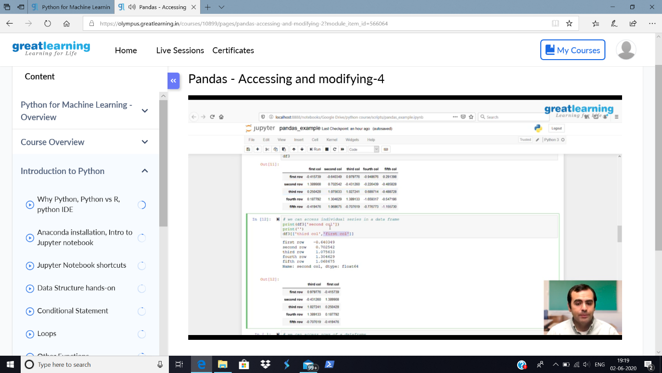

Today in the course, I have learnt about the Pandas-Accessing and modifying-4.

Then as per suggested by the HOD sir, I have taken the course Robotic Process Automation and completed it and got the certificate.

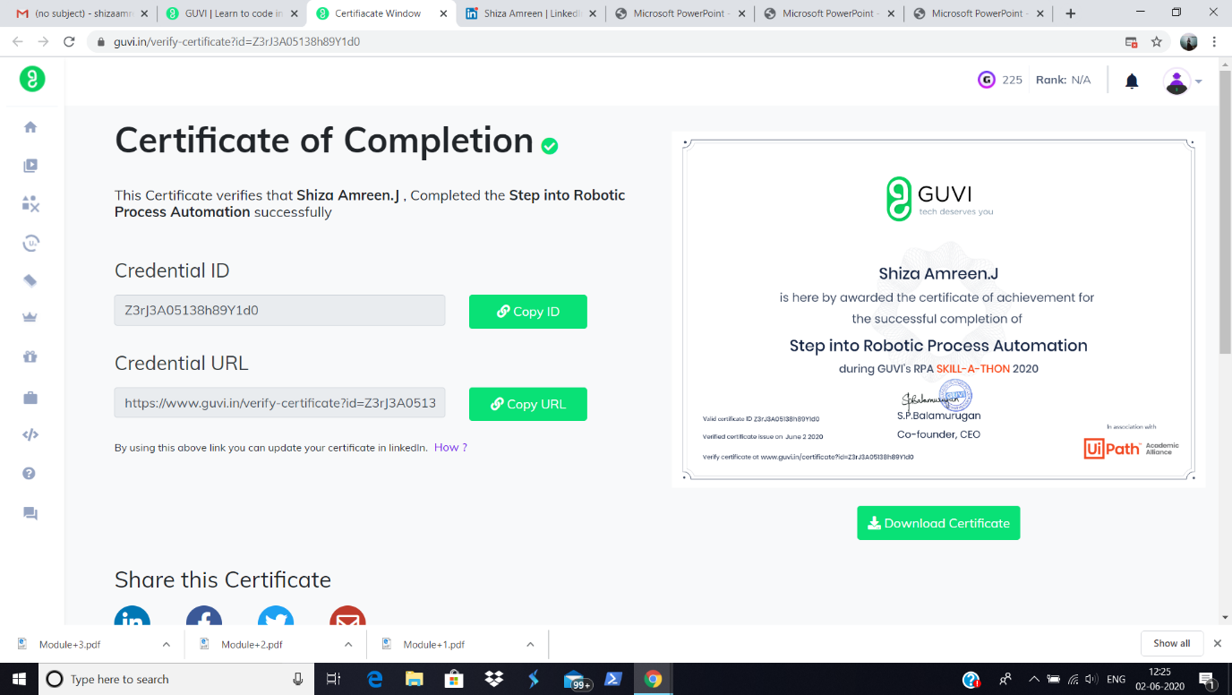

<https://www.guvi.in/verify-certificate?id=Z3rJ3A05138h89Y1d0>

Certificate:

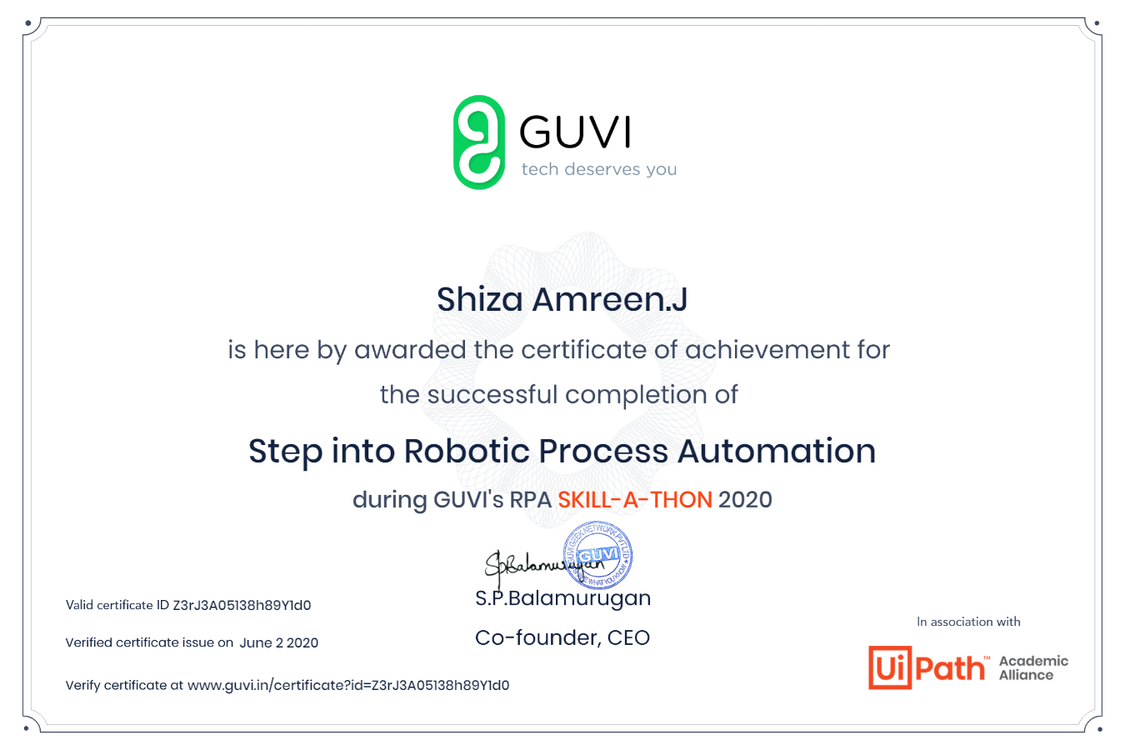

Coding Challenges Details:

**Problem Statement:**

1. **Write a C Program to find inversion count of array.**

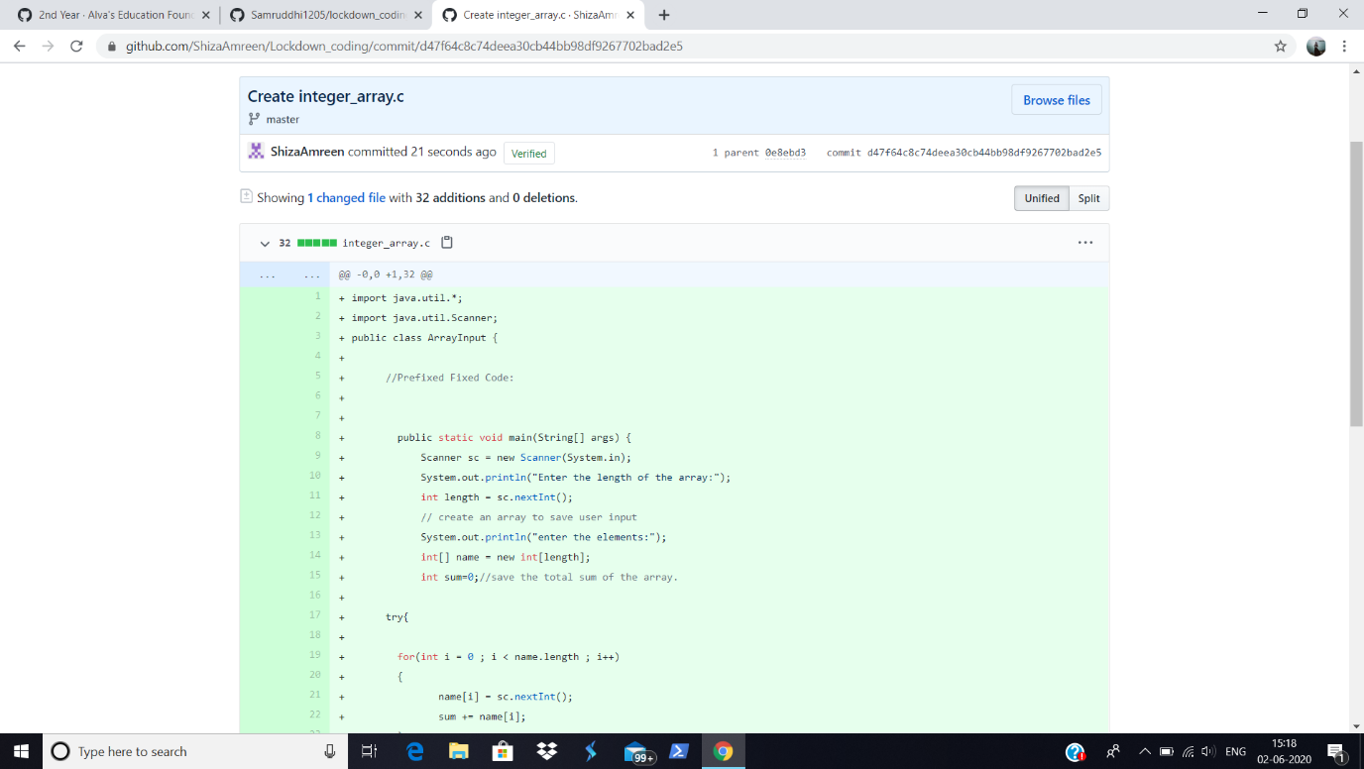

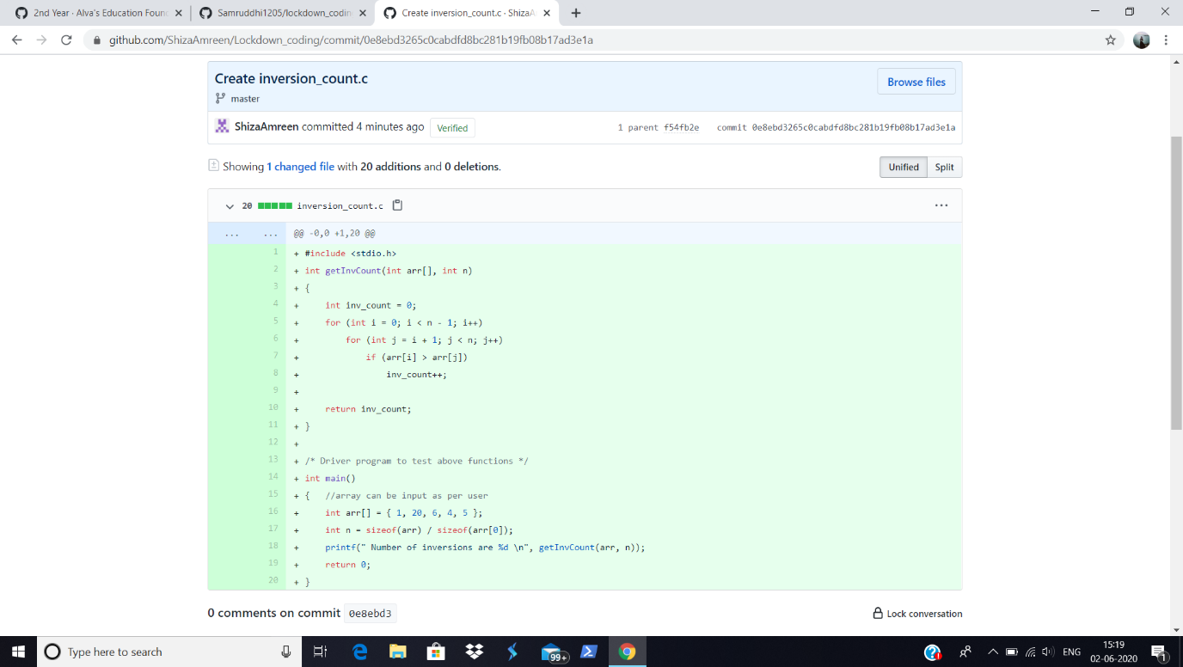

**I have written the code for above problem statements and have uploaded the code in my github repository.**

<https://github.com/ShizaAmreen/Lockdown_coding/commit/0e8ebd3265c0cabdfd8bc281b19fb08b17ad3e1a>